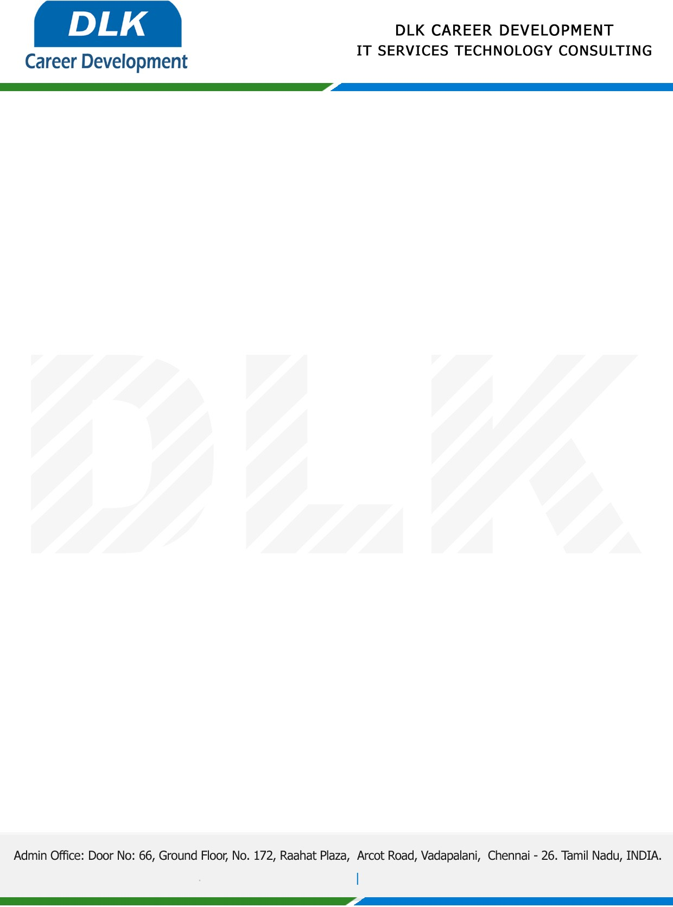

Date: 26 / December/ 2022

**To**

Department of BE –Computer Science Engineering,

Head of Department,

Velammal Engineering College, Chennai-600066.

**Sub: Letter of Internship Acceptance**

This is to certify of final year student of has accepted his Internship Work duration from **26th December 2022** to **21st January 2023** under the domain **“Web Development”.** During the internship, all information and data collected from you should be kept confidential.

**Name List:-**

1. MR SRIVATSAN R (Reg No: 113220031142)
2. MS NANDHINI K (Reg No: 113220031080)
3. MR HARISABESH M A (Reg No: 113220031042)

We appreciate your interest in **DLK CAREER DEVELOPMENT**

